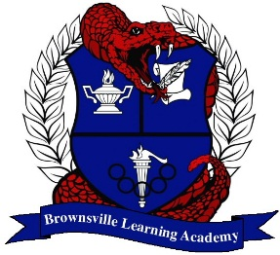
Brownsville Learning Academy

STARS Program

Courses Available in STARS
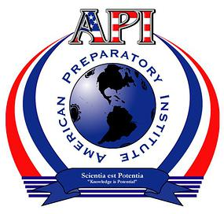 |  | 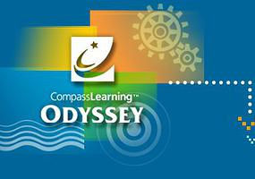
English | English | English
English 1 (2009) | English 1 | English 1
English 2 (2010) | English 2 | English 2
English 3 (2009) | English 3 | English 3
English 4 (2009) | English 4
Creative Writing (2009)
Math | Math | Math
Algebra 1 (2008) | Algebra 1 | Algebra I | Algebra II
Geometry (2006) | Algebra 2 | Geometry
 | Geometry | Pre-Calculus
Science | Science | Science
Environmental Systems (2010) | Biology | Biology | IPC
Integrated Physics & Chemistry (2007) | Chemistry | Chemistry
 | Physics | Physics
Health / PE | Health / PE
Health (2009) | Health
Advanced Health (2009) | Foundations of Personal Fitness
Foundations of Personal Fitness (2009) | Individual Sports
 | Team Sports
 | Social Studies | Social Studies
 | World Geography | World Geography
 | World History | World History
 | U.S. History | U.S. History
 | Government | Government
 | Economics
Other Courses / Electives | Other Courses / Electives | Other Courses / Electives
Anatomy & Physiology (2011) | Spanish 1 | Sociology
Art 1 (2006) | Art Appreciation
Business Info Management (2011) | Humanities
Communication Applications (2003) | Psychology
 | Sociology
Journalism (2009)
Spanish 1 (2009)
Spanish 2 (2012)

